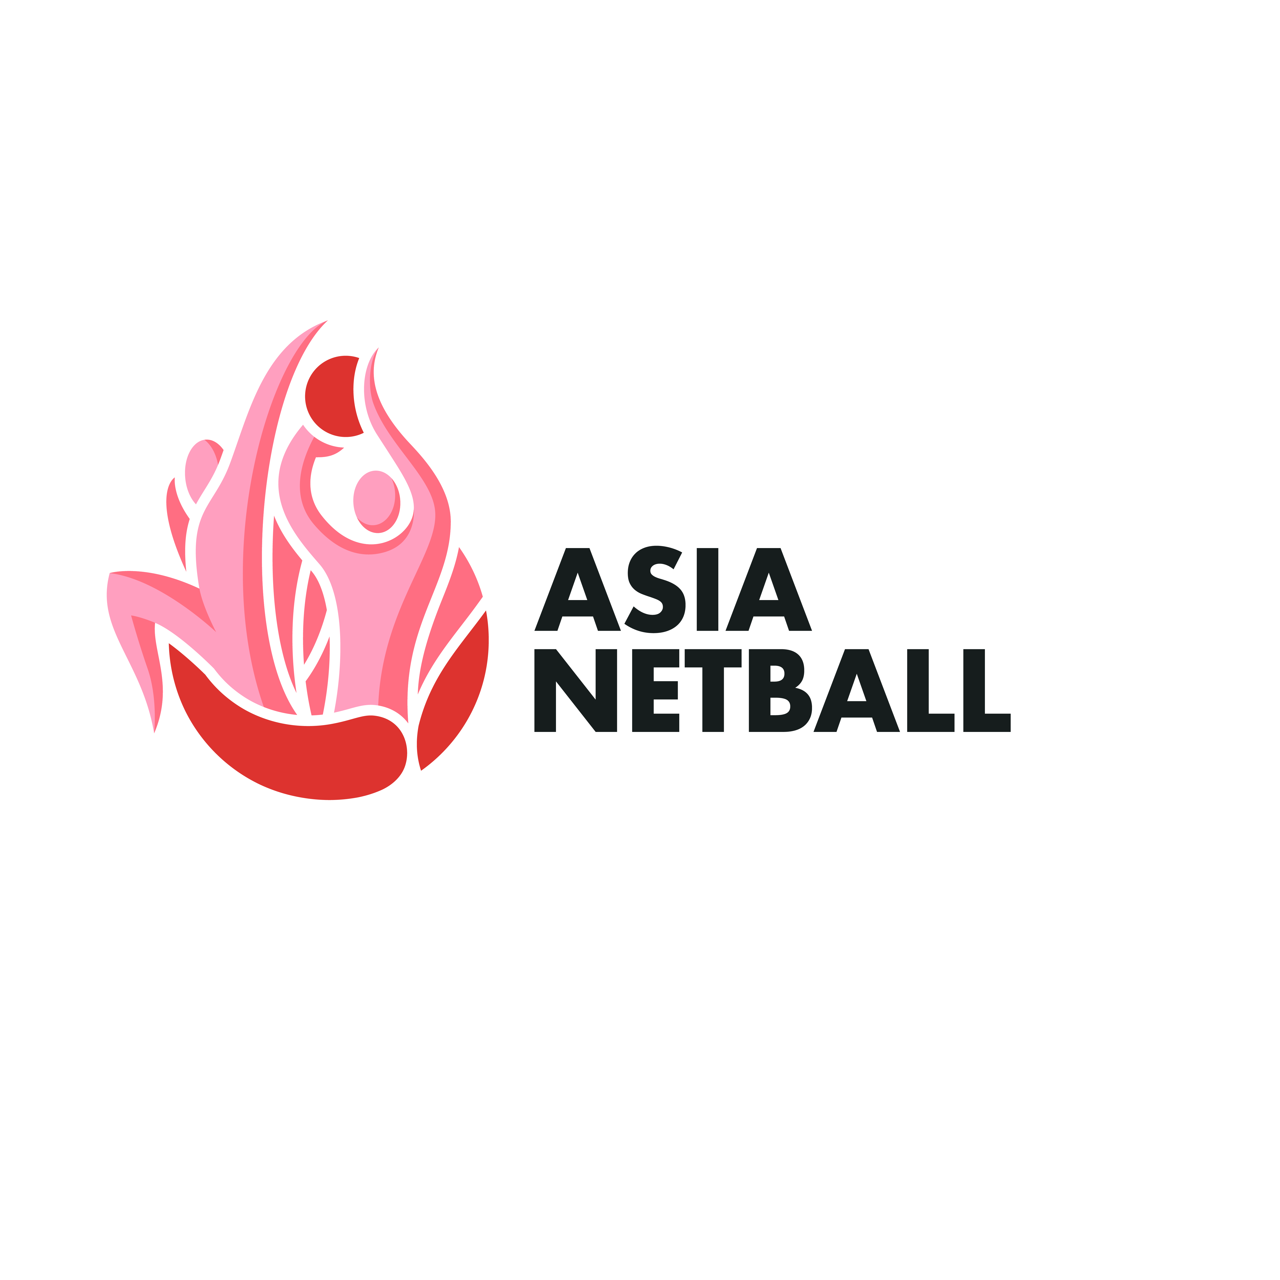
APPLICATION TO HOST
THE ASIAN NETBALL YOUTH CHAMPIONSHIPS 2023

Closing Date: 31ST March 2022

ANF Member Country:

We wish to apply to host the Asian Netball Youth Championships 2023. We have read and understood the ANF guidelines to host this event.

Please provide the following details of hosting this event:

- City

- Proposed Venue including a description of:
  - arena dimensions (playing area must be at least 120 feet x 70 feet to inlcude run-off)
  - type of flooring – eg. wood sprung, Gerflor/rubberised. Concrete floors are not acceptable.
  - type of goal posts (sunken or above ground)
  - spectator seating and
  - air conditioning.
  - Changing rooms and other facilities

- Proposed training venue as in (2) above.

- Proposed dates of the event. It should be 8 playing days with teams arriving 2 days before the event and leaving the day after the event.

- Proposed Official Hotel and Hostel, with an estimate of the cost of each. This should include breakfast and WiFi. Include the distance to the venue.

- Proposed hotel and venue for ANF AGM and lunch following.

We have read and understood our obligations for hosting the Asian Netball Youth Championships 2023, and agree to abide by the requirements.

Signature: ____________________

Name: ____________________

Position: ______________________ Date: ________________________

